Abstract Title (Times New Roman, bold, 14)
First Author¹, Second Author² and Third Author³ (Times New Roman, bold, 12)
¹ XY University, City, Postal Code, Country. (Times New Roman, 12)
² XY University, City, Postal Code, Country.
³ XY University, City, Postal Code, Country.
e-mail address of corresponding author
(the name of the presenter has to be underlined)

This template provides authors with most of the formatting specifications needed for preparing their abstract. We ask that all authors follow these guidelines and format your paper to look like this document.
The abstract must be written in English. Do not number the pages.
Do not exceed 400 words and one page.
Convert multileveled equations to graphics and insert them electronically into the text. Please ensure your graphics are clear and readable. Punctuate equations with commas or periods when they are part of a sentence, as in
       
The equation is centered. Be sure that the symbols in your equation have been defined before or immediately following the equation. Please use “(1)”, not “Eq. (1)” or “equation (1)”, except at the beginning of a sentence: “Equation (1) is . . .”
Figures or photographs must be incorporated electronically into the text. Please do not attach figures or photographs as separate files.
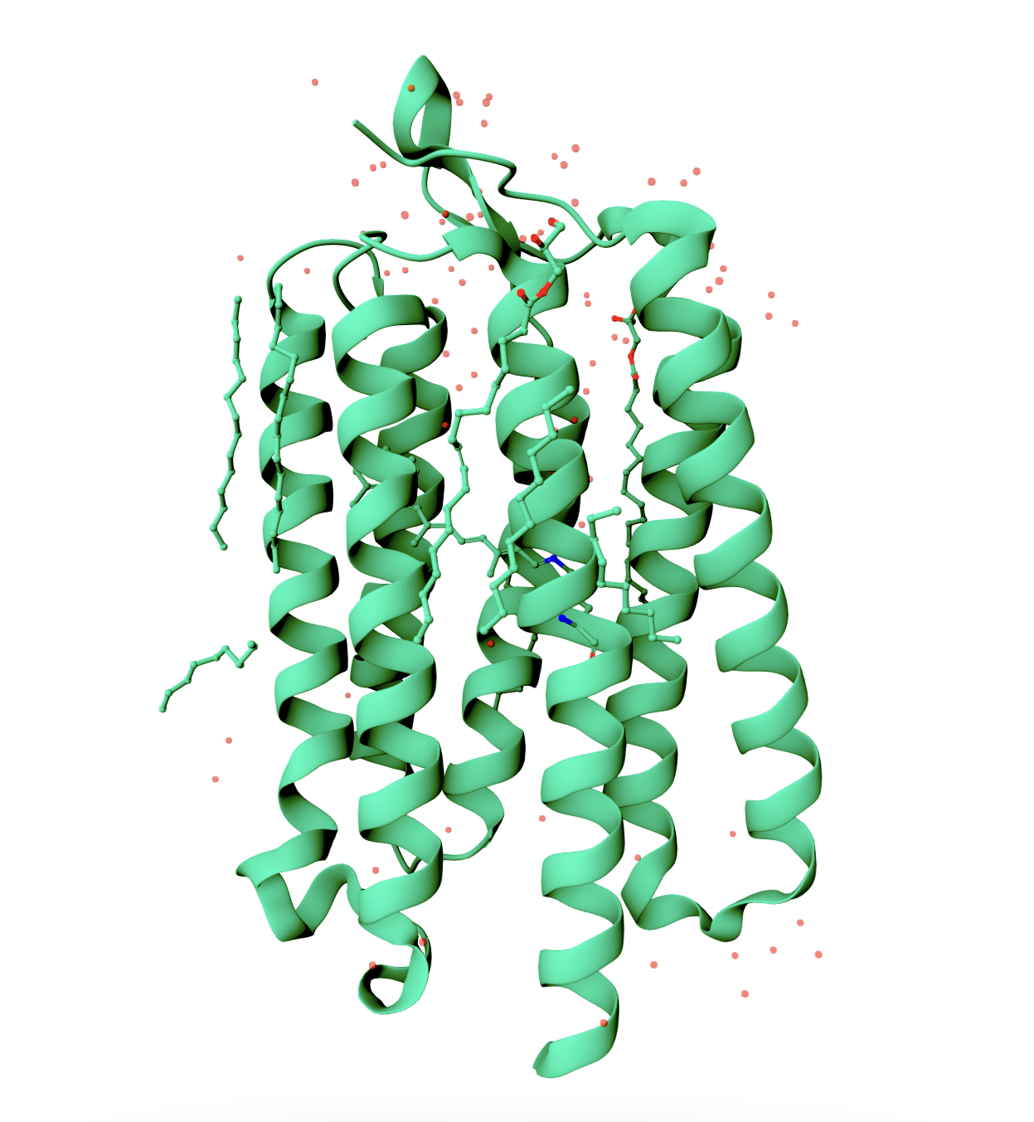
Figure 1 Example of a figure caption. (Times New Roman, bold, 10)
References are cited in the text by square brackets [1]. Please number citations consecutively within brackets. Two or more references at a time may be put in one set of brackets [1,2]. Refer to the reference number. The references are to be numbered in the order in which they are cited in the text. Do not use “Ref. [1]” or “reference [2]” except at the beginning of a sentence: “Reference [3] presented . . .”. Unless there are more than five authors, state all authors' names. (Times New Roman, 11)

References (Times New Roman, 10)
- A. Author, B. Author and C. Author, Journal Volume (Year) Firstpage.
- A. Author et al., New J. of Phys. 12. (2010). 222.
- A. Author, Book Title, edited by B. Editor (Publisher, Town, Year) pages.
- A. Author, Journal (Year) in press.
- A. Author, B. Author, C. Author, and D. Author, TMS Proceedings of ICOMAT 2008, Santa Fe, NM, June 29-July 5, 2008, (2009) 999.

